| **Experiment # 1A** | |
| --- | --- |
| **Date of Performance:- / /2024** | **Date of Submission:- / /2024** |
| **Student SAP Id:-70612400019** | |
| **Student Roll No:-A073** | |
| **Student Name:- Aryan Srivastava** | |

**RESUME with Semantics  
  
CODE:**<!DOCTYPE html>

<html lang="en">

<head>

<meta charset="UTF-8">

<meta name="viewport" content="width=device-width, initial-scale=1.0">

<title>Curriculum Vitae</title>

<style>

body {

background-color: #ffffff;

font-family: Arial, sans-serif;

margin: 40px;

}

.container {

max-width: 100%;

}

img {

display: block;

margin: auto;

}

table {

width: 100%;

border-collapse: collapse;

}

th, td {

border: 1px solid black;

padding: 8px;

text-align: left;

}

th {

background-color: #c8c8c8;

}

h2 {

text-align: left;

}

</style>

</head>

<body>

<main class="container">

<header>

<img src="nmims.png" alt="NMIMS Logo" width="160">

<h2>MCA</h2>

<p><strong>Name:</strong> Aryan Srivastava</p>

</header>

<section>

<h3>OBJECTIVE:</h3>

<p>Get a job</p>

</section>

<section>

<h3 id="education">EDUCATION:</h3>

<table>

<tr>

<th>Degree</th>

<th>Institute</th>

<th>Board/University</th>

<th>Year</th>

</tr>

<tr>

<td>MCA</td>

<td>MPSTME</td>

<td>NMIMS</td>

<td>Currently Pursuing</td>

</tr>

<tr>

<td>BSC CS</td>

<td>Mithibai</td>

<td>Mumbai University</td>

<td>2024</td>

</tr>

<tr>

<td>XII</td>

<td>Royal College</td>

<td>MHT</td>

<td>2021</td>

</tr>

<tr>

<td>X</td>

<td>RBK School</td>

<td>ICSE</td>

<td>2019</td>

</tr>

</table>

</section>

<section>

<h3 id="technical_skills">TECHNICAL SKILLS:</h3>

<table>

<tr>

<th>Domain</th>

<th>Details</th>

</tr>

<tr>

<td>Languages</td>

<td>Dart, JavaScript, Python</td>

</tr>

<tr>

<td>Web Designing</td>

<td>HTML, CSS, JavaScript, Flutter</td>

</tr>

<tr>

<td>Software</td>

<td>Flutter, Node.js</td>

</tr>

<tr>

<td>Database</td>

<td>Firebase, MongoDB</td>

</tr>

<tr>

<td>Analytics</td>

<td>Google Analytics</td>

</tr>

<tr>

<td>Operating Systems</td>

<td>Windows, Linux</td>

</tr>

</table>

</section>

<section>

<h3>KEY PROJECTS:</h3>

<table>

<tr>

<th>Project Title</th>

<th>Duration</th>

<th>Platform Used</th>

<th>Brief Description</th>

</tr>

<tr>

<td>Flutter E-commerce App</td>

<td>6 months</td>

<td>Flutter, Firebase</td>

<td>Developed a full-featured e-commerce application with user authentication, product catalog, and real-time database integration.</td>

</tr>

<tr>

<td>University Management System</td>

<td>4 months</td>

<td>Node.js, MongoDB, React</td>

<td>Created a comprehensive university management system to handle student data, course registrations, and faculty management.</td>

</tr>

</table>

</section>

<section>

<h3>TECHNICAL – WORK EXPERIENCE / INTERNSHIPS:</h3>

<ul>

<li>

<strong>Company:</strong> Tech Solutions<br>

<strong>Role:</strong> Mobile App Developer Intern<br>

<strong>Duration:</strong> January 2023 - June 2023<br>

<strong>Description:</strong> Worked on developing and maintaining mobile applications using Flutter. Contributed to the development of new features and bug fixes.

</li>

<li>

<strong>Company:</strong> Software Pvt Ltd<br>

<strong>Role:</strong> Frontend Developer Intern<br>

<strong>Duration:</strong> July 2023 - December 2023<br>

<strong>Description:</strong> Assisted in designing and implementing user interfaces for web applications using React. Collaborated with backend developers to integrate APIs.

</li>

</ul>

</section>

<section>

<h3>TECHNICAL – PRESENTATION/WORKSHOPS/CERTIFICATION</h3>

<ol type="I">

<li>Program 1

<ul>

<li>Workshop A</li>

<li>Certification A</li>

</ul>

</li>

<li>Program 2

<ul>

<li>Workshop B</li>

<li>Certification B</li>

</ul>

</li>

</ol>

</section>

<nav>

<h3>Links</h3>

<p><a href="#technical_skills" target="_self">Go to Technical Skills</a></p>

<p><a href="#education" target="_blank">Open Education in a new tab</a></p>

</nav>

</main>

</body>

</html>

**OUTPUT**

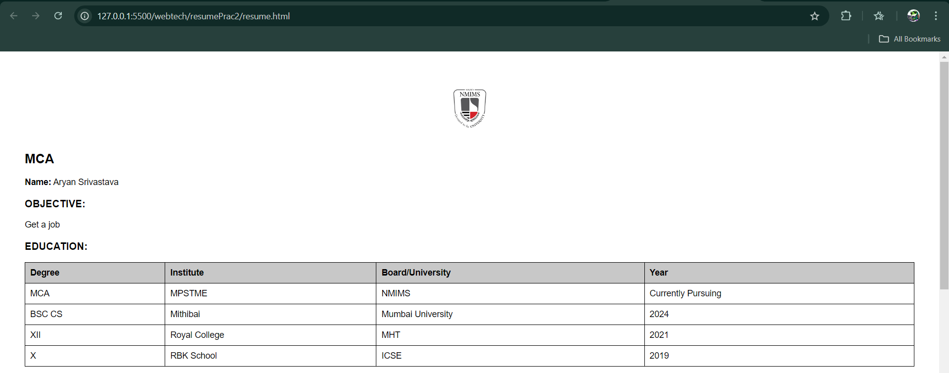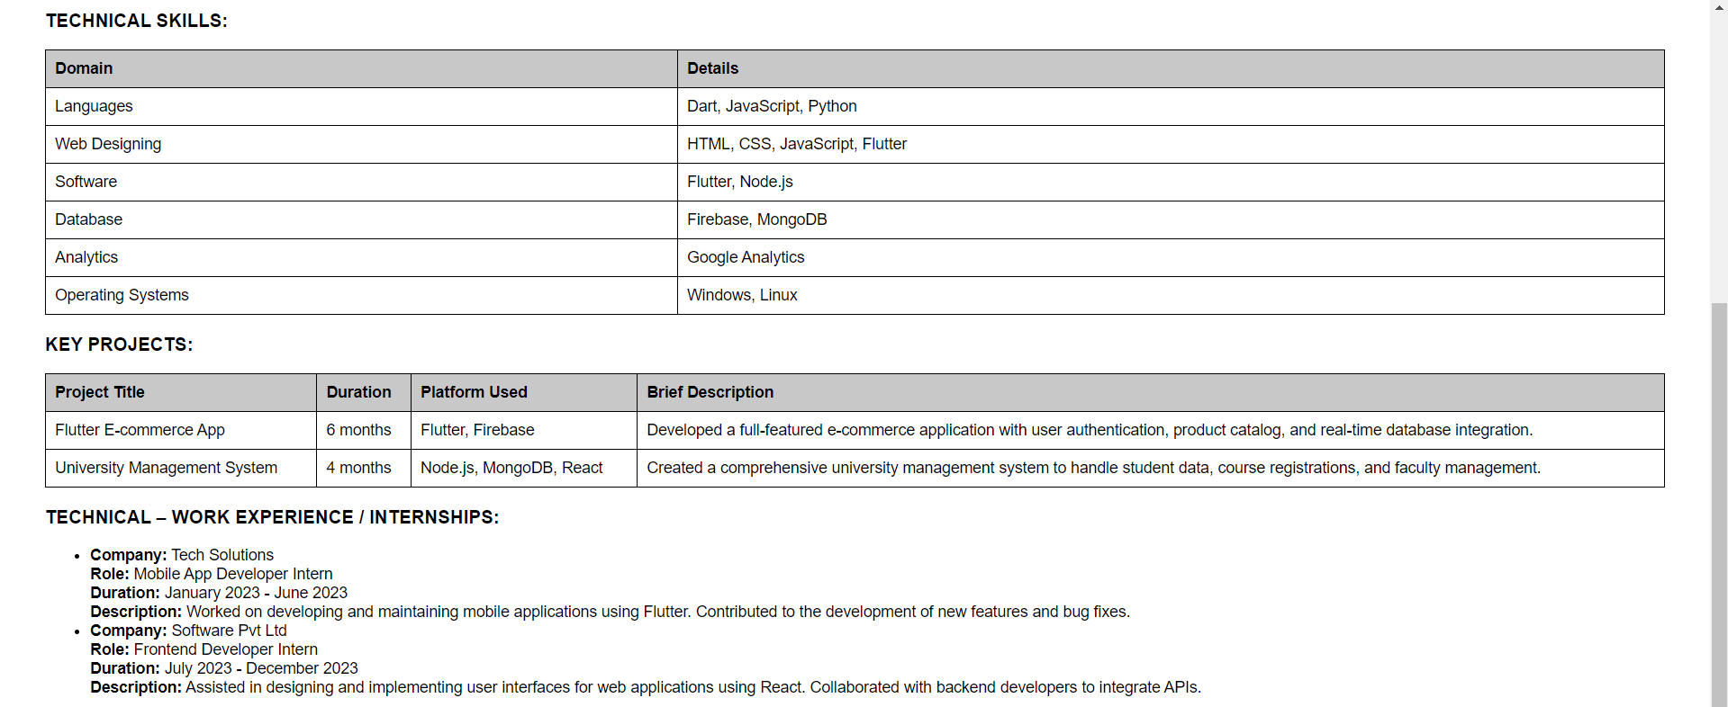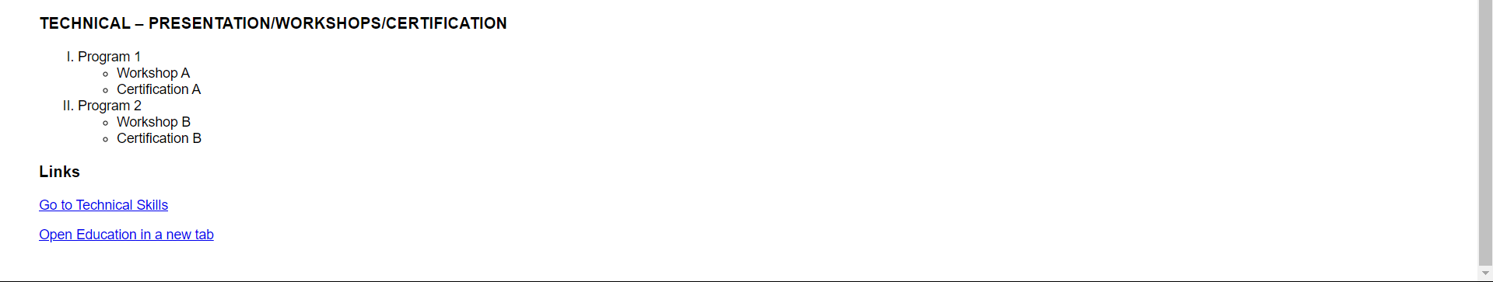

**Observation and Learning: -**

* **Successfully implemented semantic tags. behavour and charactersticts**

**Answer the Questions:-**

